15.83: a) For a string, 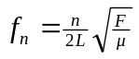 and in this case, 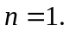 Rearranging this and solving for F gives 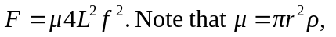
Substituting values,
b) To find the fractional change in the frequency we must take the ration of 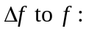
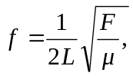
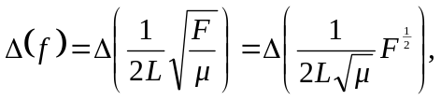
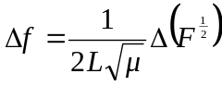
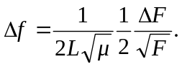

Now divide both sides by the original equation for and cancel terms:

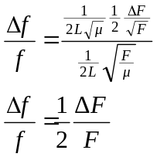
c) From Section 17.4, 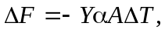 so
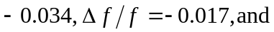finally,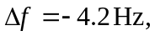or the pitch falls. This also explains the constant the constant tuning in the string sections of symphonic orchestras.

